Ex. No. : 02 Name: Shreya Amudhu.N.R

Register No. : 2116240701505

A Comparative Study of Low-Code Application Development vs. Traditional Application Development

1. Aim
The aim of this study is to critically compare Low-Code Application Development with Traditional Application Development as two distinct approaches to building software applications. The study examines their respective development lifecycles, technical and operational characteristics, advantages, and limitations, and illustrates the practical difference between the two approaches through a common example application built using both methods. The overall goal is to help developers, project managers, and organisations make an informed choice of development approach based on project requirements, timelines, budget, and available technical expertise.

2. Introduction
Software application development has traditionally required specialised programming knowledge, structured planning, and considerable time investment. In recent years, however, the emergence of low-code development platforms has changed how applications are conceived and built, enabling faster delivery with reduced dependency on hand-written code. This section introduces both approaches before they are compared in detail in the sections that follow.

2.1 Low-Code Application Development
Low-code application development refers to a software development approach that uses visual, drag-and-drop interfaces, pre-built templates, and configurable components to build applications with minimal hand-written code. Platforms such as Zoho Creator, Microsoft Power Apps, OutSystems, and Mendix allow developers — including citizen developers with limited programming background — to design forms, automate workflows, and connect to databases through visual builders rather than traditional programming languages. Low-code platforms typically bundle the user interface designer, business logic engine, database, and deployment infrastructure into a single integrated environment, which significantly shortens the path from idea to working application.

2.2 Traditional Application Development
Traditional application development refers to the conventional method of building software by writing source code manually using programming languages such as Java, Python, C#, or JavaScript, combined with separate tools for database design, version control, testing, and deployment. This approach follows well-established software engineering practices such as requirement analysis, system design, implementation, testing, and maintenance, typically executed by skilled developers or development teams. It offers complete control over architecture, performance tuning, and integration but generally requires a longer development cycle and greater technical expertise.

3. Objectives of the Study
- To understand the core concepts and working principles of low-code and traditional application development.
- To compare the development lifecycle of both approaches stage by stage.
- To analyse both approaches across key parameters such as development time, cost, flexibility, scalability, and required skill set.
- To demonstrate the practical difference between the two approaches using a common illustrative example.
- To identify the advantages and limitations inherent to each approach.
- To draw conclusions on the suitability of each approach for different categories of projects.

4. Development Lifecycle Comparison
Although both approaches ultimately aim to deliver a working application, the sequence, duration, and nature of activities involved differ substantially. Figure 1 illustrates the typical stages followed in each lifecycle.
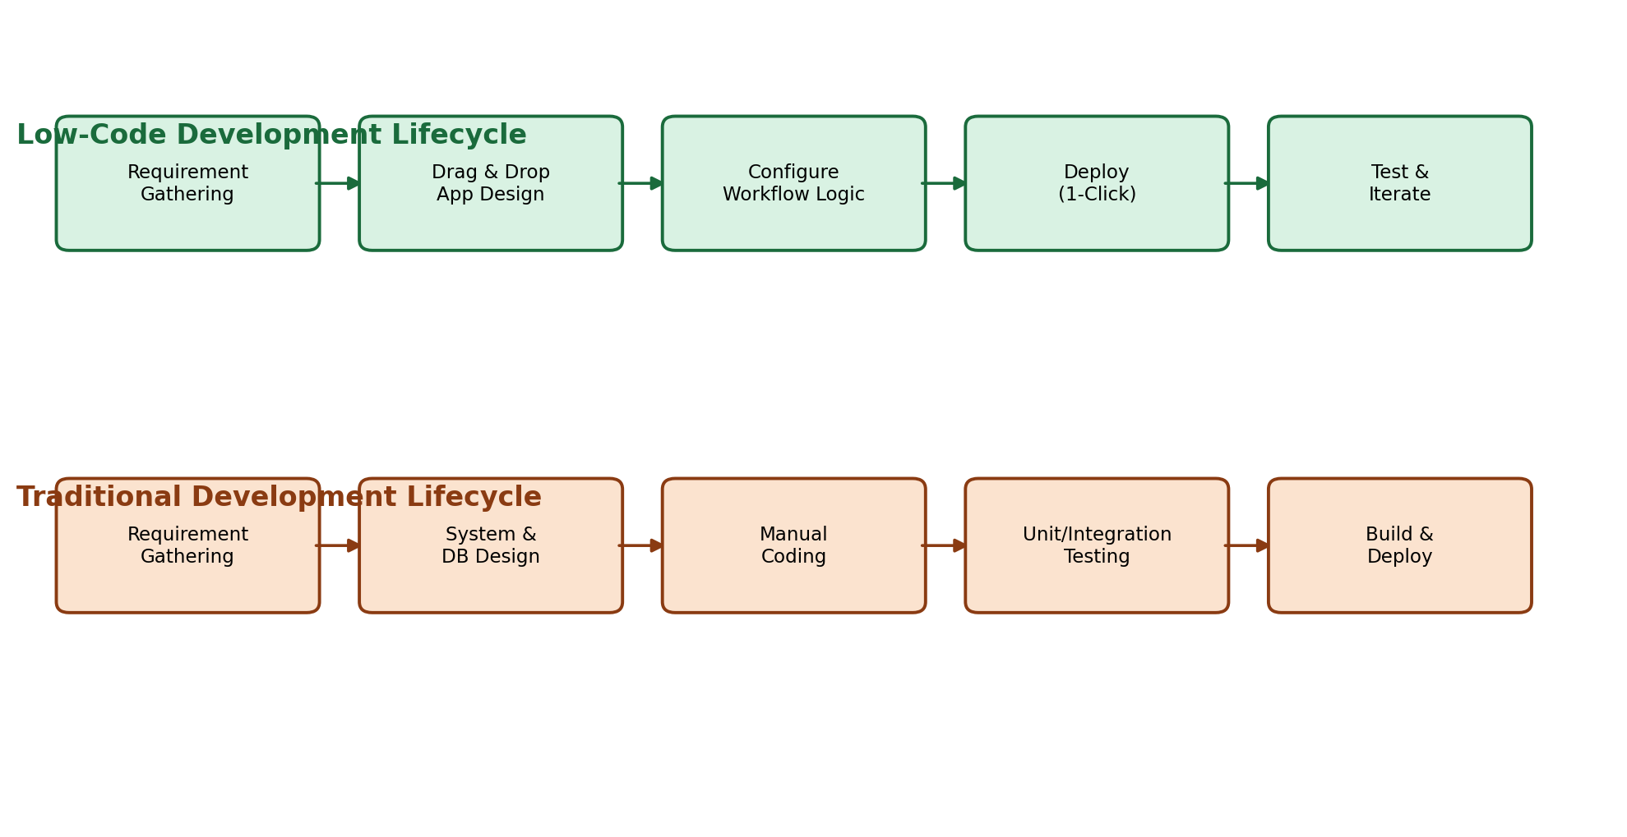
Figure 1: Development Lifecycle — Low-Code vs Traditional Development
In low-code development, the requirement-gathering stage feeds directly into visual application design, where forms, pages, and layouts are created using drag-and-drop builders. Business logic is then configured through visual workflow rules rather than written code, and the application can be deployed with a single click, followed by rapid iterative testing. In traditional development, the same starting point leads to a more elaborate path involving formal system and database design, manual coding of every module, structured unit and integration testing, and a separate build-and-deployment phase — each of which demands dedicated technical effort and coordination between team members.
Lifecycle Stage | Low-Code Approach | Traditional Approach
Requirement Gathering | Same as traditional; business needs documented | Formal requirement specification (SRS)
Design | Visual/drag-and-drop UI design | System architecture, ER diagrams, wireframes
Implementation | Configuration of workflows and business rules | Manual coding in a programming language
Testing | Built-in rapid testing/preview | Dedicated unit, integration, and system testing
Deployment | One-click publish within the platform | Build pipeline, servers, and release management
Maintenance | Platform-managed updates and patches | Manual code maintenance and refactoring
Table 1: Stage-wise Comparison of the Development Lifecycle

5. Detailed Comparative Analysis
This section presents a parameter-wise comparison between low-code and traditional development, covering both quantitative and qualitative aspects of the two approaches.
Parameter | Low-Code Development | Traditional Development
Development Speed | Very fast (days to weeks) | Slower (weeks to months)
Coding Skill Required | Minimal to moderate | High (proficient programmers needed)
Customization | Limited by platform capabilities | Virtually unlimited
Cost (Initial) | Lower; subscription-based | Higher; development and infrastructure cost
Cost (Long-term) | Recurring licensing fees | One-time build, ongoing maintenance cost
Scalability | Good for small-to-medium apps | Excellent for large, complex systems
Integration Flexibility | Pre-built connectors; limited for niche systems | Full control over APIs and integrations
Maintenance Effort | Low; platform-managed | High; requires dedicated developers
Time-to-Market | Very short | Comparatively long
Vendor Dependency | High (platform lock-in) | Low (technology-agnostic)
Table 2: Parameter-wise Comparative Analysis
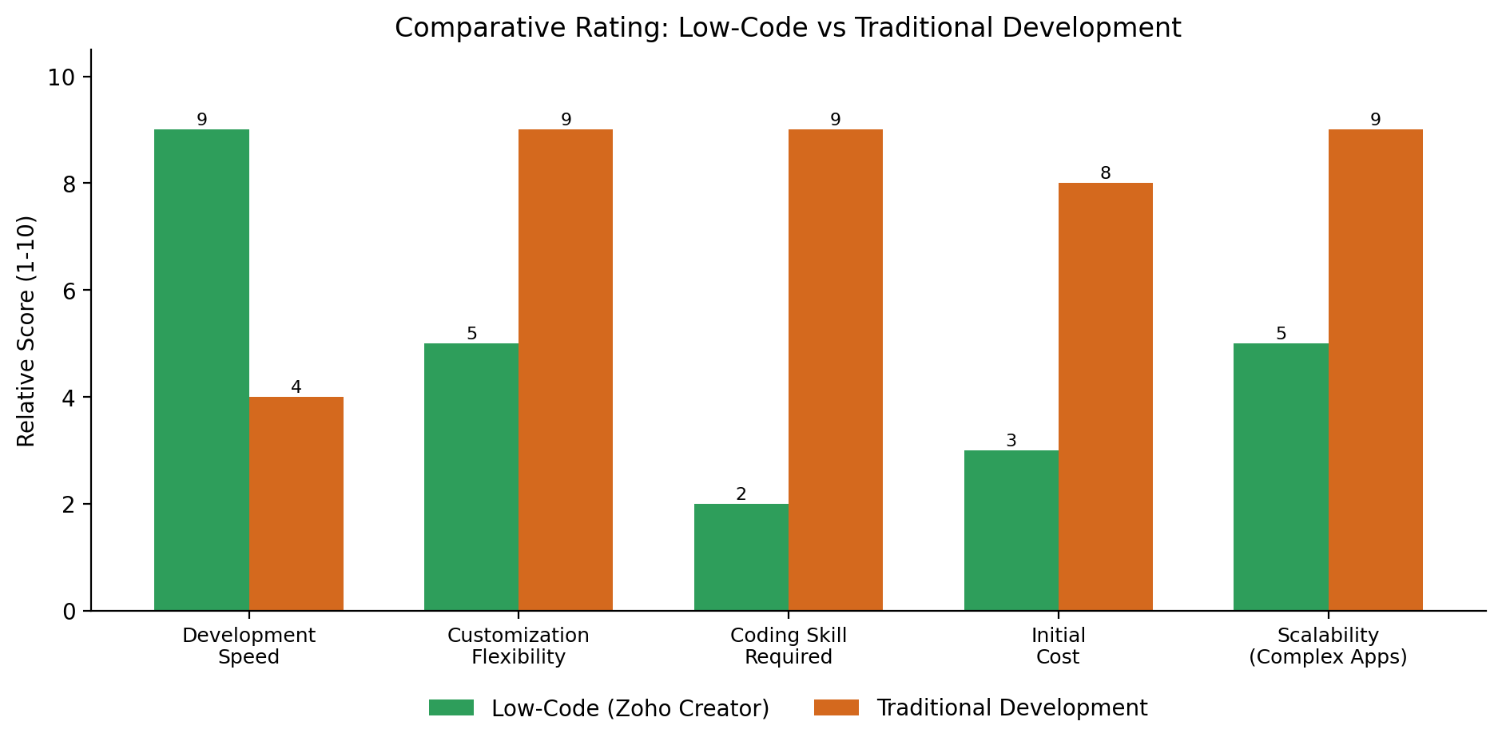
Figure 2: Relative Comparative Rating of Low-Code vs Traditional Development (Scale 1–10)

6. Illustrative Example
To make the comparison concrete, both approaches are illustrated below using a common example: an Employee Leave Management Application that allows employees to apply for leave, and managers to approve or reject requests.

6.1 Using Zoho Creator (Low-Code)
Building the Employee Leave Management application in Zoho Creator involves the following steps:
- Create a new application and add a form titled "Leave Request" using the drag-and-drop form builder, with fields such as Employee Name, Leave Type, From Date, To Date, and Reason.
- Define a workflow rule that automatically routes a submitted request to the employee's reporting manager for approval.
- Configure an approval field with buttons for "Approve" and "Reject", triggering an automated email notification to the employee using a built-in email action — no code required.
- Design a dashboard report showing pending, approved, and rejected requests using Zoho Creator's visual report builder.
- Publish the application instantly using the "Deploy" option, making it accessible via web and mobile without separate hosting setup.
The entire application can typically be built and deployed within one to three days by a single citizen developer with no formal programming background, since all logic is configured visually rather than coded.

6.2 Using Traditional Development
Building the same application using a traditional stack (for example, a Java/Spring Boot backend, a MySQL database, and a React front end) involves the following steps:
- Design the database schema manually, creating tables for Employees, LeaveRequests, and Approvals with defined relationships and constraints.
- Develop backend REST APIs in Java/Spring Boot for submitting, retrieving, approving, and rejecting leave requests, including validation and business logic written as code.
- Build the front-end user interface in React, including forms, tables, and approval screens, and integrate them with the backend APIs.
- Implement authentication, role-based access control, and email notification logic manually using libraries such as Spring Security and JavaMail.
- Write unit and integration tests, then configure a CI/CD pipeline and deploy the application to a server or cloud instance (e.g., AWS or Azure).
This same application, built by a small team of experienced developers, would typically require two to four weeks of effort covering design, coding, testing, and deployment — considerably longer than the low-code equivalent, but resulting in an application with greater long-term flexibility for customisation.

7. Advantages and Limitations

7.1 Low-Code Development — Advantages
- Significantly faster development and deployment cycles.
- Reduces dependency on highly skilled programmers; enables citizen development.
- Lower upfront development cost for small-to-medium applications.
- Built-in hosting, security patches, and platform maintenance.
- Visual debugging and rapid iteration/prototyping.

7.2 Low-Code Development — Limitations
- Limited customization beyond what the platform natively supports.
- Risk of vendor/platform lock-in and recurring licensing costs.
- May not scale efficiently for very large or highly complex enterprise systems.
- Restricted control over performance tuning and low-level architecture.
- Integration with legacy or highly specialised systems can be difficult.

7.3 Traditional Development — Advantages
- Complete control over architecture, performance, and technology stack.
- Virtually unlimited customization to meet unique business requirements.
- Better suited for large-scale, high-complexity, or mission-critical systems.
- No dependency on a third-party platform's roadmap or pricing changes.
- Easier to optimise for specific performance or security requirements.

7.4 Traditional Development — Limitations
- Longer development timelines and higher initial cost.
- Requires skilled developers and larger, coordinated teams.
- Higher long-term maintenance effort and technical debt risk.
- Slower response to changing business requirements.
- Greater upfront investment in infrastructure and DevOps setup.

8. Result
The comparative analysis shows that low-code development offers a clear advantage in development speed, cost-efficiency, and accessibility for small-to-medium applications with standard business logic, as demonstrated by the Employee Leave Management example being built in a matter of days using Zoho Creator. Traditional development, while slower and more resource-intensive, offers superior flexibility, scalability, and control, making it the more suitable choice for large, complex, or highly customised enterprise systems. The choice between the two approaches is therefore not a question of one being universally "better", but of selecting the approach that best matches the project's scale, complexity, timeline, budget, and long-term maintenance requirements.

9. Conclusion
Low-code and traditional application development represent two complementary rather than competing paradigms in modern software engineering. Low-code platforms such as Zoho Creator democratize application development, enabling rapid delivery of functional business applications with minimal coding expertise, and are particularly well suited to internal tools, workflow automation, and rapid prototyping. Traditional development, on the other hand, remains indispensable for building complex, highly scalable, and deeply customised systems where long-term control over the technology stack is essential. Organisations are increasingly adopting a hybrid strategy — using low-code platforms for routine or time-sensitive applications while reserving traditional development for core, mission-critical systems — thereby leveraging the strengths of both approaches.

10. References
1. Zoho Creator Official Documentation — https://www.zoho.com/creator/
2. Microsoft Power Apps Documentation — https://learn.microsoft.com/power-apps/
3. OutSystems Low-Code Platform Documentation — https://www.outsystems.com/
4. Gartner, "Magic Quadrant for Enterprise Low-Code Application Platforms."
5. Sommerville, I., Software Engineering, 10th Edition, Pearson Education.
6. Pressman, R. S., Software Engineering: A Practitioner's Approach, McGraw-Hill Education.

